A000-Eur-Crete-Knossos Palace-Minoan Snake Goddess with Leopard Snakes and Cat Snakes-1600 BCE

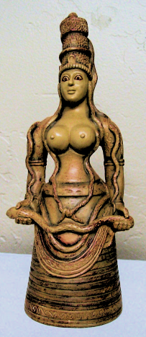

Eur-Crete-Knossos Palace-Minoan Snake Goddess with Leopard Snakes and Cat Snakes-1600 BCE

**Case no.: 4**

**Accession Number:**

**Formal Label:** Eur-Crete-Knossos Palace-Minoan Snake Goddess with Leopard Snakes and Cat Snakes-1600 BCE

**Display Description:**

Cretan Minoan Snake Goddess of Knossos Statue Her staring gaze denotes an oracular role of this Goddess who appears to be in a trance with her snake companions. She depicts the power of the life force, holding one of the most beautiful of all European snakes, the leopard snake (*Elaphe situla*), common throughout low-lying parts of Crete. One other leopard snake adorns her apron. Unfortunately, this handsome reptile does sport a V-shaped marking behind its head, leading many to confuse it with the deadly northern European adder. Its Greek name is Ochendra.

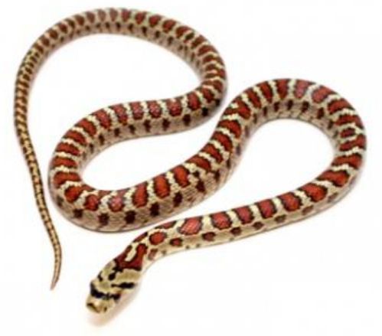

The leopard snake (*Elaphe situla*), after <https://www.bebesaurus.com/4927-home_default/zamenis-situla-couleuvre-leopard.jpg>

In addition, the goddess’s body is entwined with a swarm of four cat snakes (*Telescopus fallax*) which are mildly venomous to rodents but harmless to humans as the venom fangs are situated at the back of the mouth cavity. Serpents are metaphorically associated with immortality, as they periodically have to shed their old skins in a metaphoric death to re-emerge into a new, larger skin.

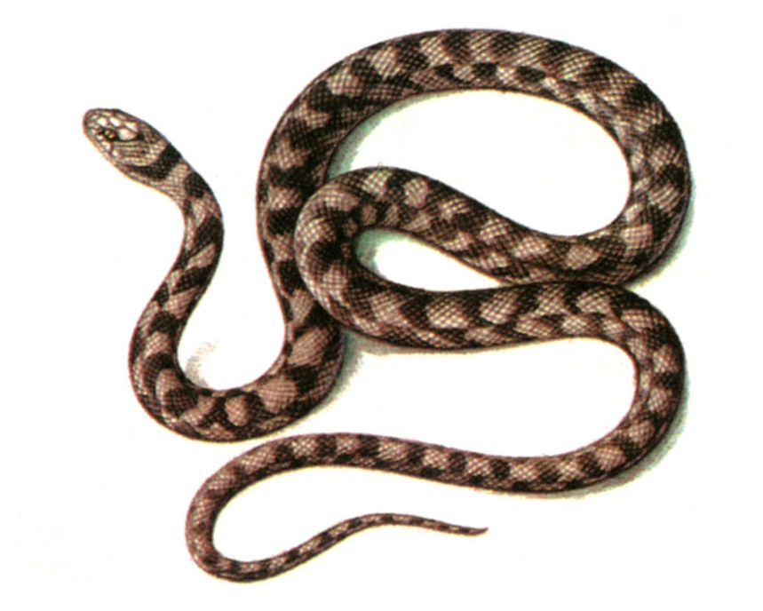

Cat snake (*Telescopus fallax*), after http://www.sevin.ru/redbook/content/230spbig.html

This figurine’s crown has an entwining cat snake. The original was found in a storage room in the Palace of Knossos, Crete. She is a votive offering and not a cult figure and therefore, probably represents a Priestess who is perhaps a princess of the palace. Although she is dressed in the garb of her deity, a Cretan Earth Mother, she is a personification of Earth from which all life springs and returns.

Knossos was the ceremonial and political center of the Minoan civilization and culture. The palace was abandoned at the end of the Late Bronze Age, c. 1380–1100 BCE which coincides with the raids of the “Sea Peoples” throughout the Mediterranean. This faïence figurine identified as a "Snake Goddess" was discovered in 1903 by Sir Arthur Evans in the so-called Temple Repositories on the site of the "palace" of Knossos. Most of the faïence pieces were found in the Eastern Repository. This headdress is embellished with poppies suggesting that a hallucinogenic libation accompanied the rites to this goddess.

**LC Classification** DF221.C8

**Date or Time Horizon:** 1600 BCE

**Geographical Area:** Temple Repositories on the site of the "palace" of Knossos, Crete

**Map**

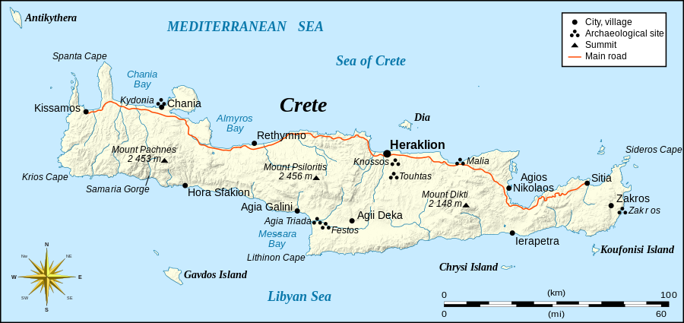

Eric Gaba ([Sting](https://commons.wikimedia.org/wiki/User:Sting)) - Own work, based on [Image:Crete_topographic_map-fr.svg](https://commons.wikimedia.org/wiki/File:Crete_topographic_map-fr.svg) (modified and translated) created by myself ; Compass rose : [Image:Brújula.svg](https://commons.wikimedia.org/wiki/File:Br%C3%BAjula.svg) (modified) created by [Serg!o](https://commons.wikimedia.org/wiki/User:Serg%21o) under GFDL

**GPS Coordinates:** 35°17'31.59" N 25°09'28.41" E

**Cultural Affiliation:** Neopalatial period, 17th century BCE 

**Geographical Area: Knossos, Crete**

**Medium:** Faience. The figurines are made of faience, a technique for glazing earthenware and other ceramic vessels by using a quartz paste. This material symbolized in old Egypt the renewal of life, therefore it was used in the funeral cult and in the sanctuaries. After firing this produces bright colors and a lustrous sheen.

**Dimensions:** H. 0.335 m

**Weight: ca 3 lbs, 1.4 kg**

**Condition:** replica, Herakleion Museum, Crete, Greece

**Provenance:** replica, faience, Herakleion Museum, Crete, Greece

**Discussion:**

Part of one of the figurines was found in the Western Repository, which indicated to Evans that the contents of the Eastern depository had been considerably disturbed at some period, probably by plunderers at the time of the destruction of the "palace" by an earthquake around 1600 BCE. Evans implies that the faïence objects were broken at this time and most of the fragments swept into the Eastern Repository when the palace was rebuilt. Though the figurines must have been in existence before then, they are usually dated to the time of their destruction, around 1600 BCE.

They are probably (according to Burkert) related with the Paleolithic tradition regarding women and domesticity. The figurines have also been interpreted as showing a mistress of animals-type goddess and as a precursor to Athena Parthenos, who is also associated with snakes.

**References:**

Evans, Arthur. 1902-03. "The Palace of Knossos," Annual of the British School in Athens, 9:1-153.   
Evans, Arthur. 1921-1935. The Palace of Minos, 4 vols. London: Macmillan.

Gesell. Geraldine Cornelia. 1985. Town, Palace, and House Cult in Minoan Crete, Göteborg: Paul Åstroms Förlag.

**Appendix: original figurine,** Herakleion Museum, Crete, Greece.

